3. Bed Fan Assembly

The bed fan is optional. It lowers the cool down period when the parts are finished.

Vitamins
4 M4 cap screw x 34mm  1 Fan 80mm x 26mm | 4 Nyloc nut M4  4 Washer M4 x 9mm x 0.8mm

Printed part
1 fan_guard.stl
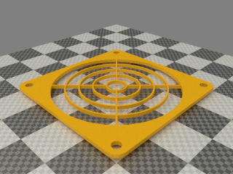

Assembly
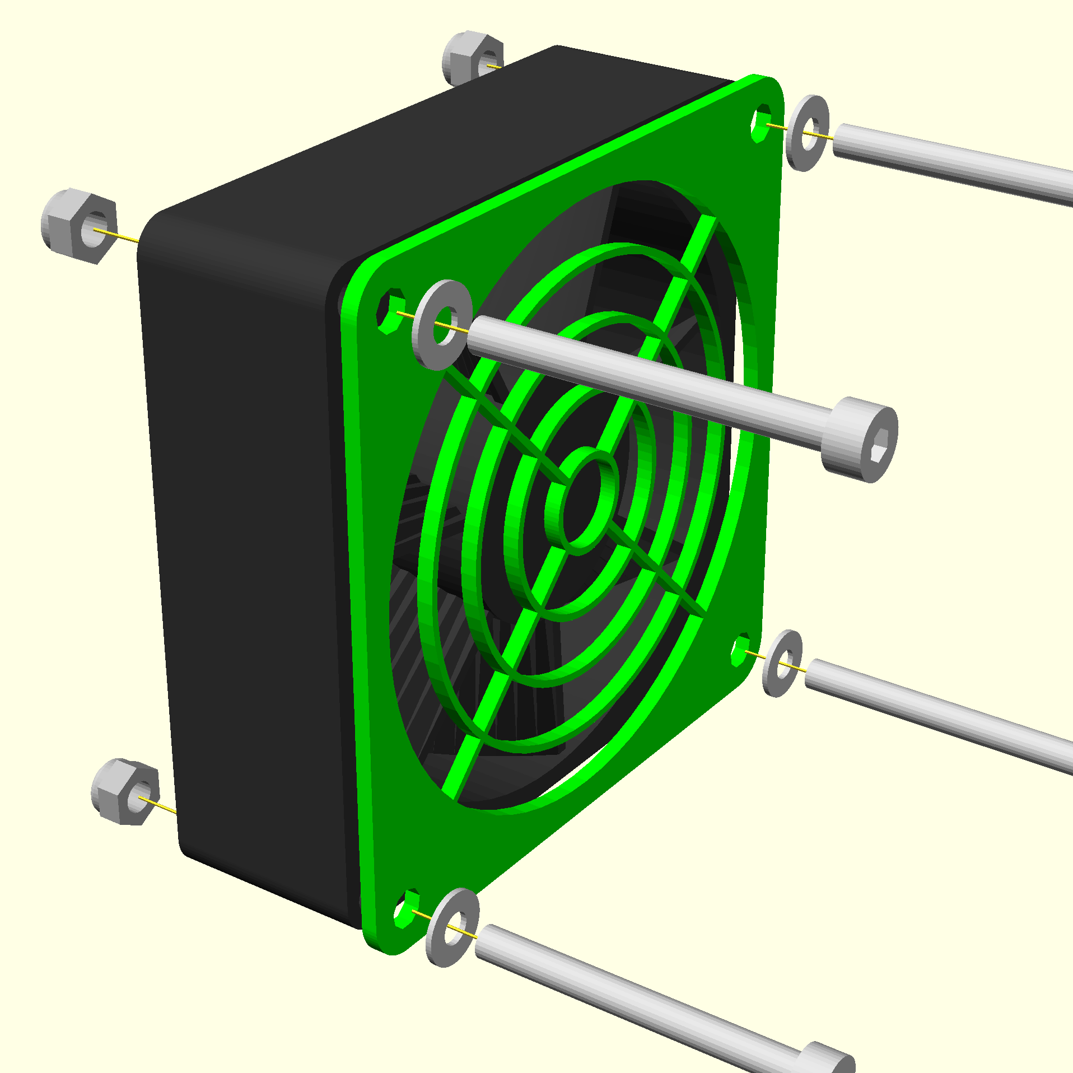

Make sure the fan is blowing inwards. This is usually indicated by an arrow on the frame and is often the side with the label.
The four screws pass through a plain washer, the fan guard, the left stay, the fan and finally a nyloc nut.
Twist the wires and route them on top of the base to electronics bay
It should look like this when done
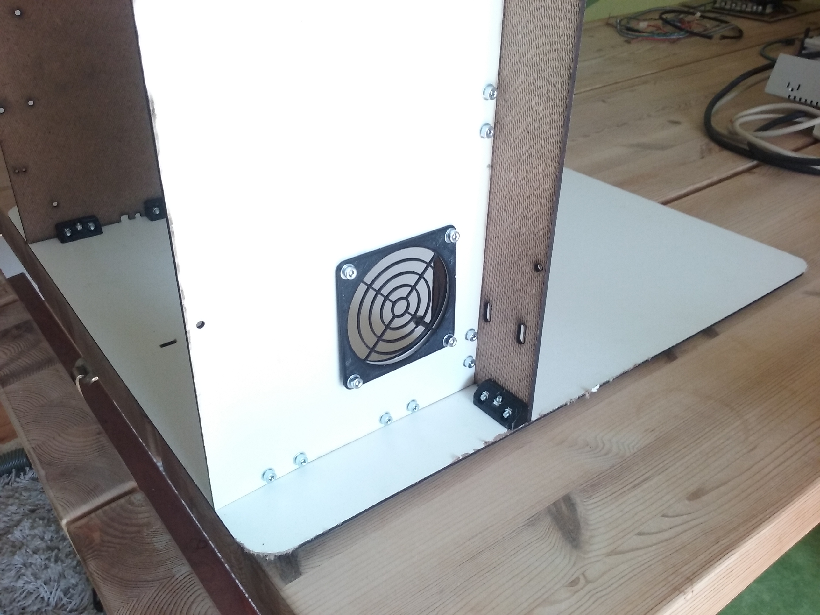

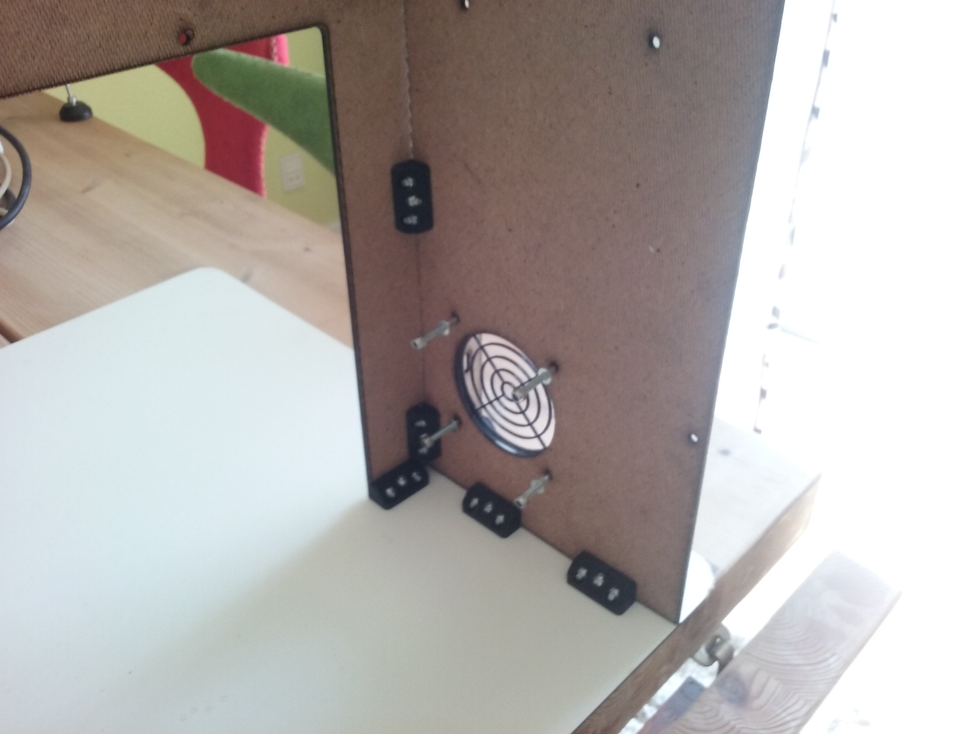
Note that there has been added extra washers. Thou not required it will help spread the load on the fan when its added.

